
ASN & Shipping Label Supplier Handbook
v2.5 06/05/10

This handbook is a step by step process for WEB Edi suppliers. It details how to create ASN’s and the print the associated shipping labels in order to comply with Methode’s logistical process necessary for correct receipt of goods.

The system requirements for this process include:

Internet Access
WEB Edi Log In & Password - obtained by contacting your assigned Methode Electronics Material Scheduler
Java – free download from the web
Label Printer – As specified
External Label feeder – Optional but highly recommended
Label Size: 4”(wide) x 6”(long) = 101.6mm(wide) x 152.4mm(long)
Print Stock : Thermal Direct (No Ribbon)

Important: Kindly liaise with your Material Scheduler to ensure your parts have been set up to print through WEB Portal and your standard packs have been set.

In case of any questions contact Methode Help Desk as follows:
Contact Person: Gabriel Cassar Torregiani
Tel: +356 2389 2010
E-mail: Gabriel.CassarTorregiani@methode-eur.com

The ASN Process

Important information about ASN processing:-
- It is normal practice for ASN’s messages to be posted shortly before material is picked up from your company. Once an ASN is posted by the supplier on WEB Edi, this data will be transmitted directly into Methode’s ERP system. At this point no changes are to be made to the ASN and associated Labels. It is important to note that the ASN and labels are directly linked to each other and one may not mix labels not specifically created from that ASN.
- When considered as a qualified supplier, the following is the list of documentation we will be requiring for each shipment:-
  - Delivery note/Invoice with the goods
  - Invoice for payment by mail (as applicable)

Logging onto the web site

1) Type http:// b2b.methode-eur.com/ in your browser and skip the welcome page

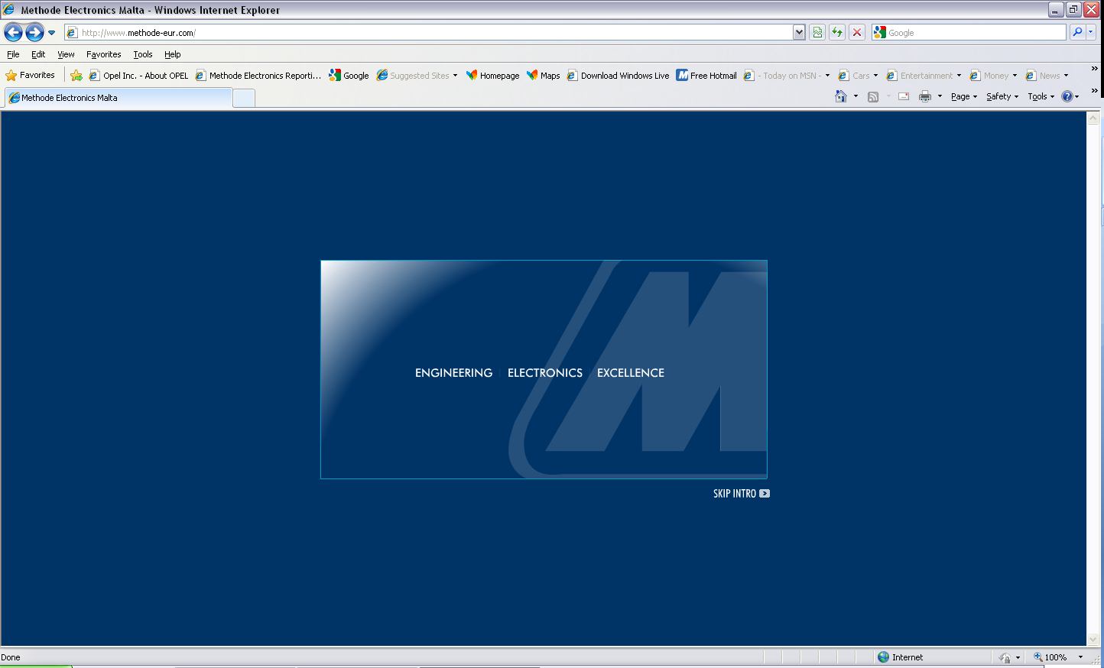

2) This will take you to the home page. Move your mouse pointer over the Supplier Portal Menu (in the top right corner) and click on E-Business when this choice becomes available

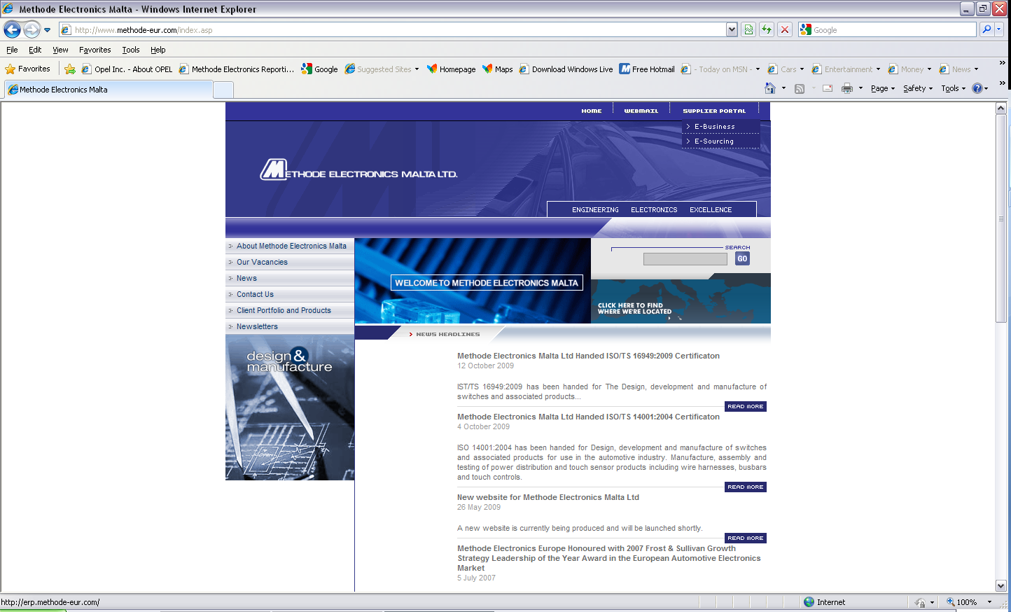

3) This will take you to the sign-on page as below

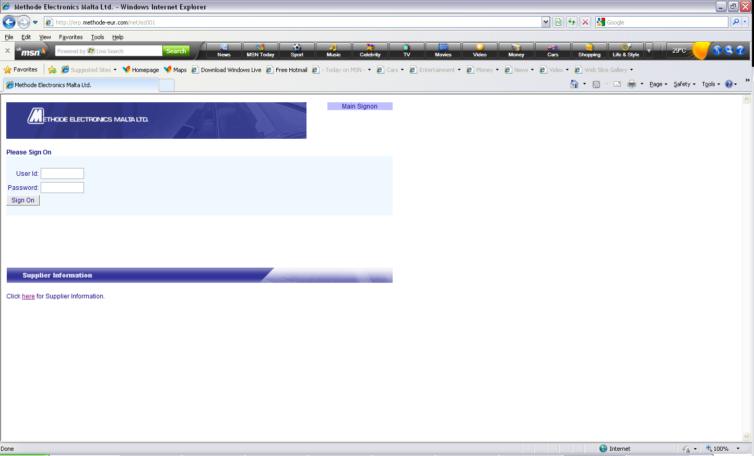

4) Enter user ID & Password and click on Tab.
Sign On

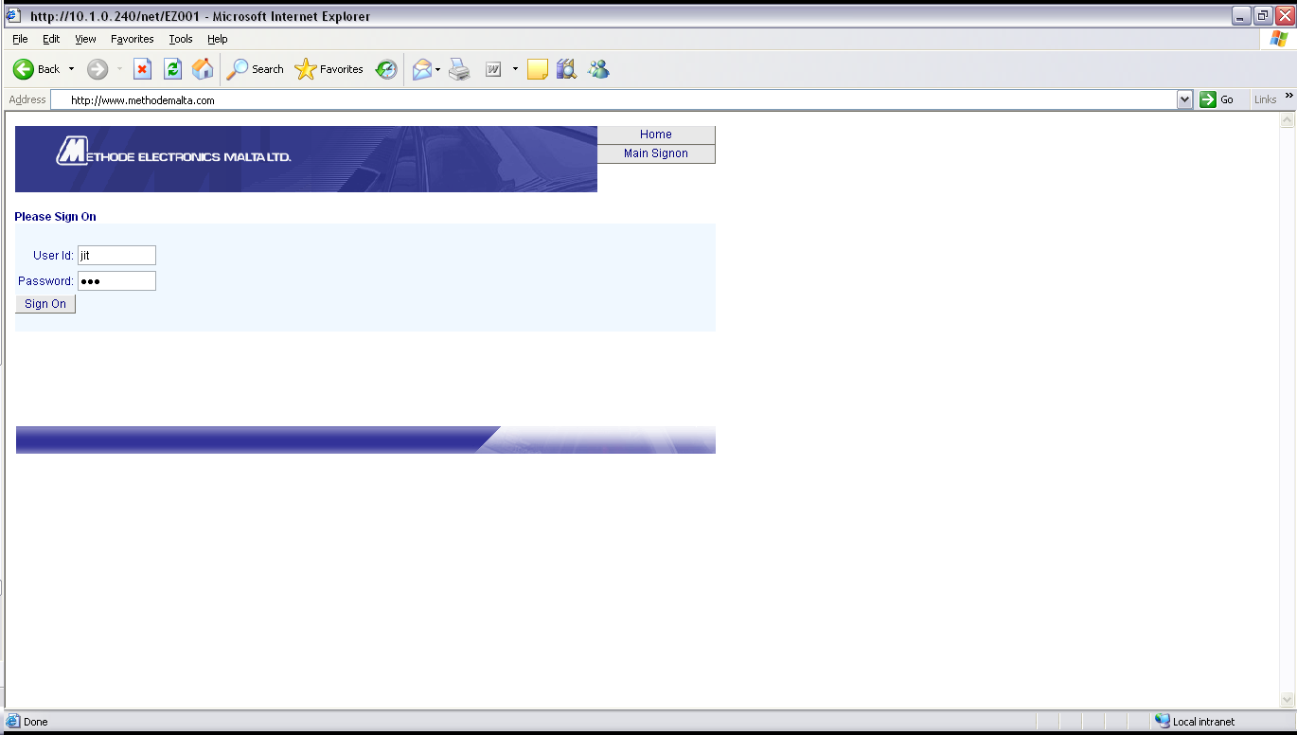

Creation of Advance Shipping Notice & Serialized Labels
ASN

- The creation of an ASN message starts by first clicking on the Tab as shown hereunder.(Note that the number of buttons available to the supplier may differ from this screenshot)

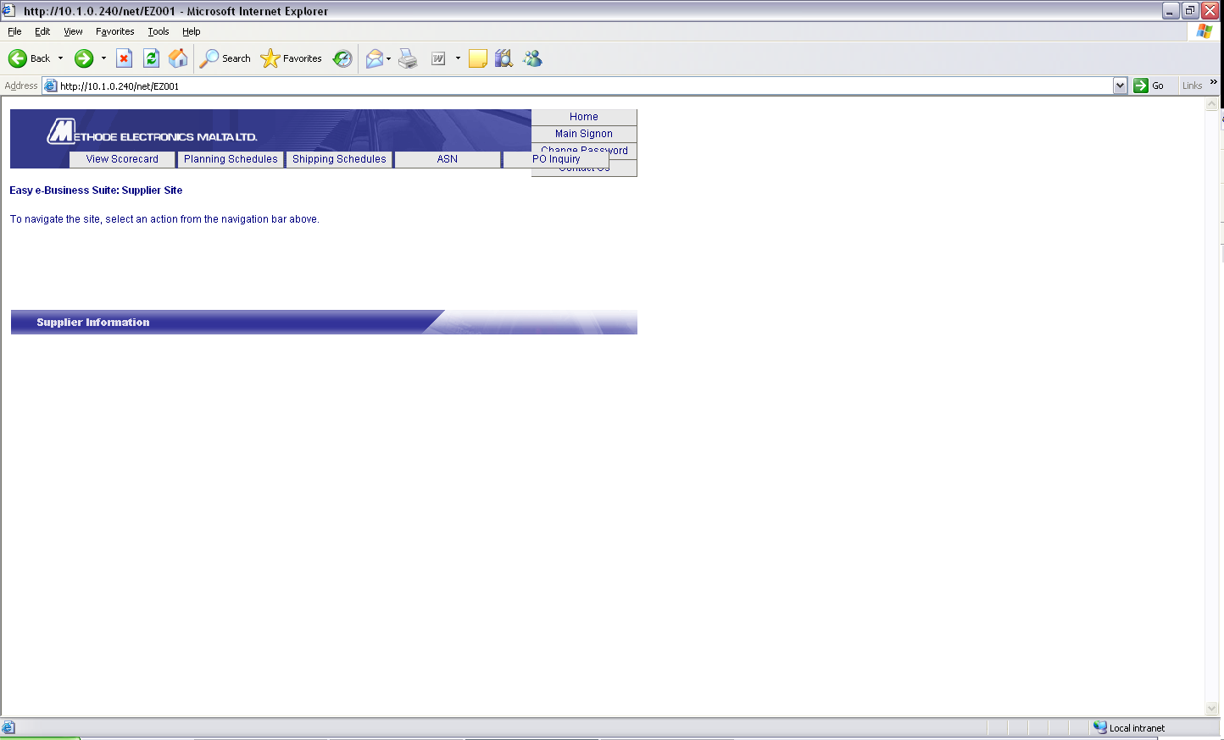
A. Click

Create New ASN
- Click on Tab

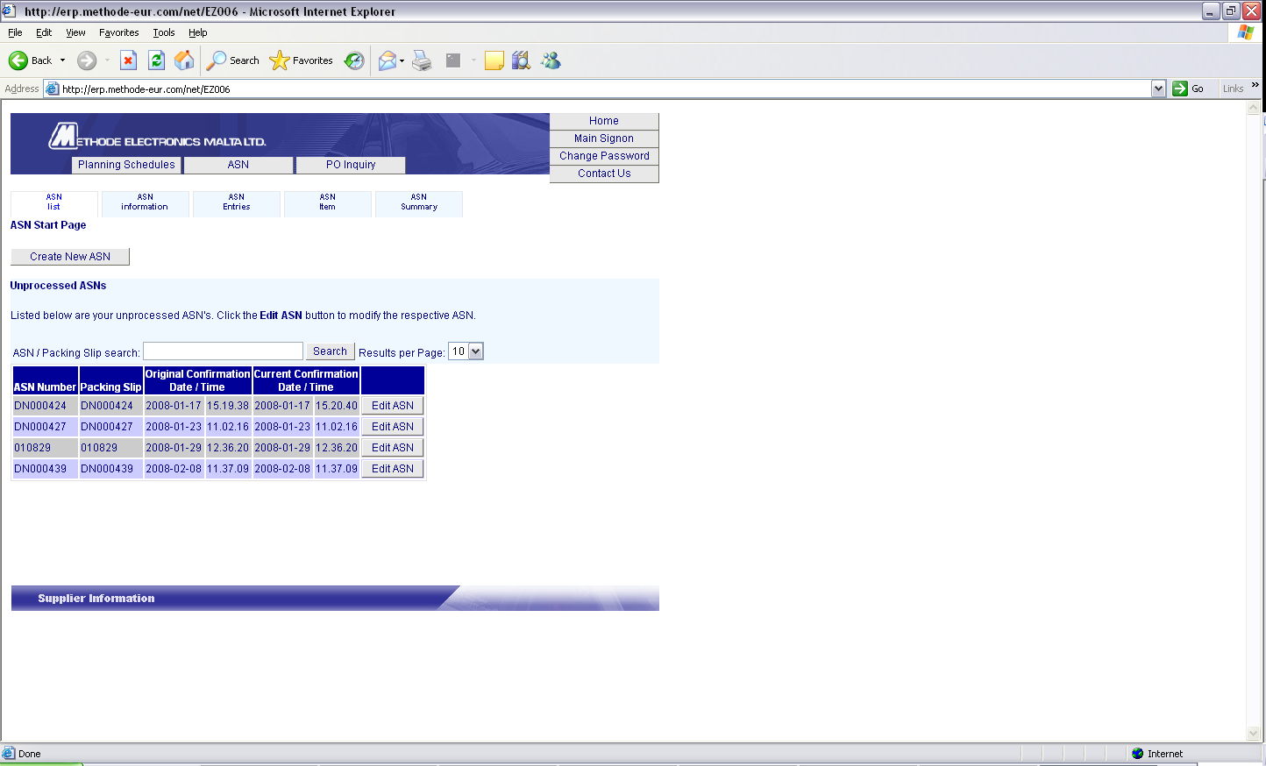
B. Click

- Supplier will be required to update the ASN header information. The minimum fields that need to be entered are the following:-
    - ASN Number
b) Packing Slip Number (equal to the ASN number & matching the delivery note/invoice accompanying the goods)
c) Ship Date/Time
d) Expected Date/Time (Ex-works suppliers – dates are to be the same. DDU suppliers – Expected Date/Time is to be equal to the approximate delivery date at Methode)
e) SCAC Code (equal to the carrier name)
f) Carrier Name (name of agent pickup up the cargo from supplier premises)
g) Air Bill Number (tracking number. Applicable for airfreight deliveries only)
h) Number of containers (total number of pallets/loose cartons)
i) Gross Weight (total weight of the material. Equal to what is declared on the delivery documents)

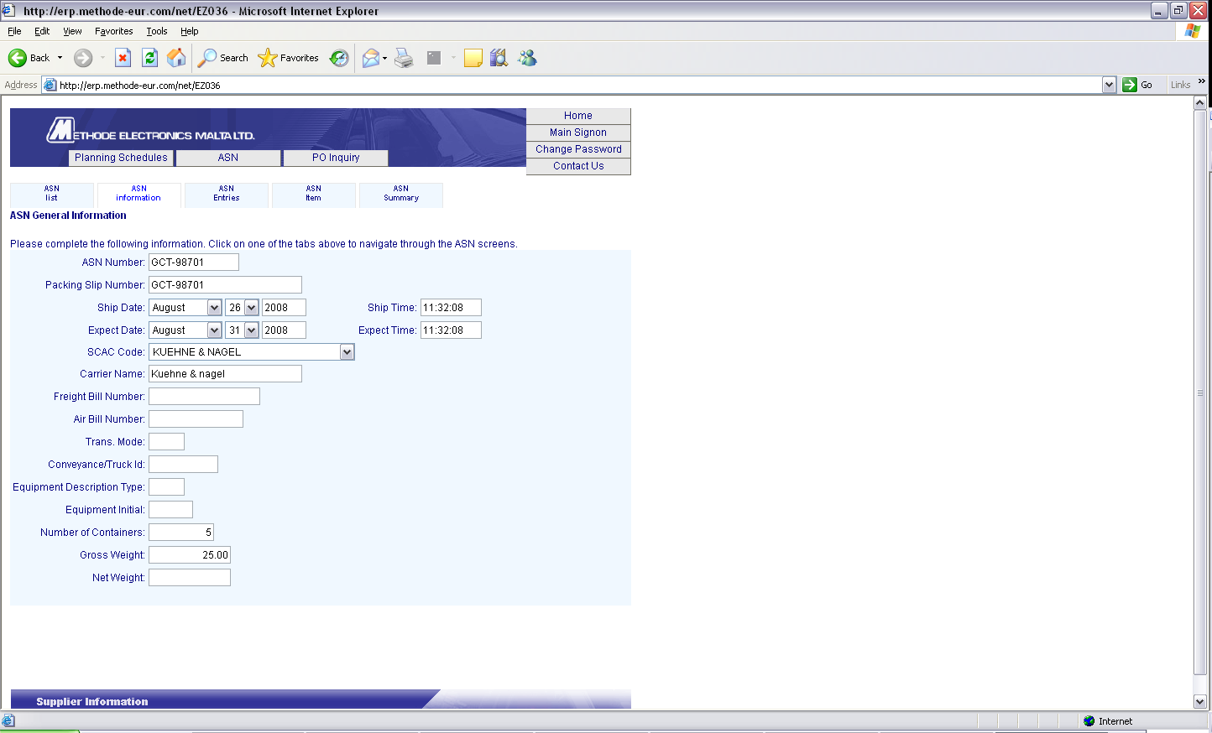
C. Enter Minimum Data as stipulated above
D. Click

ASN Entries

- Click on Tab as indicated in the screenshot (Part D) above. This will move you to the next screen. Select the Purchase order/Part number to be included in the delivery by clicking on the Tab (Part E).
Update

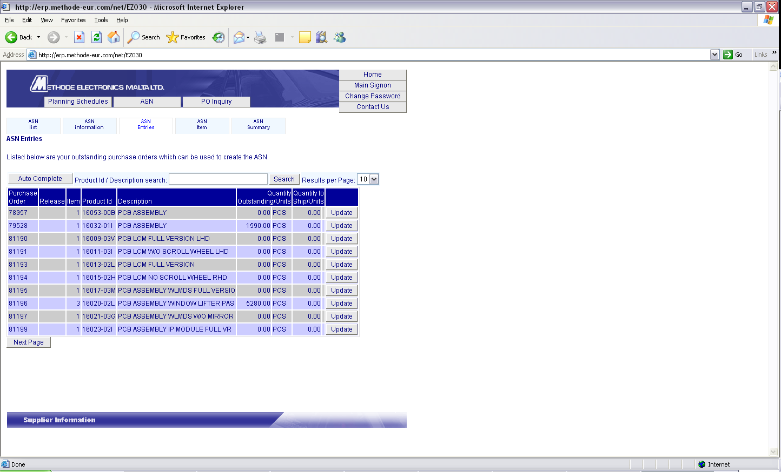
E. Click on
of the required Purchase Order
Update

- Software will take you to the next screen whereby you will be required to enter the quantity being shipped. Press the Tab.
Save

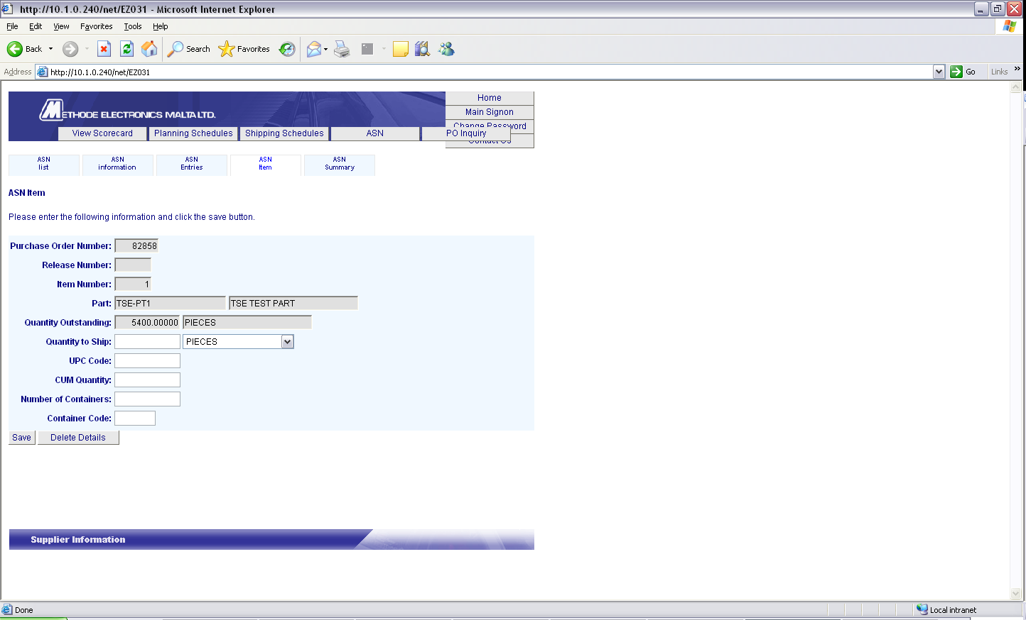
F. Enter Quantity to be shipped
G. Press Tab
Save

New Sub-Detail

- Press Tab to create labels.

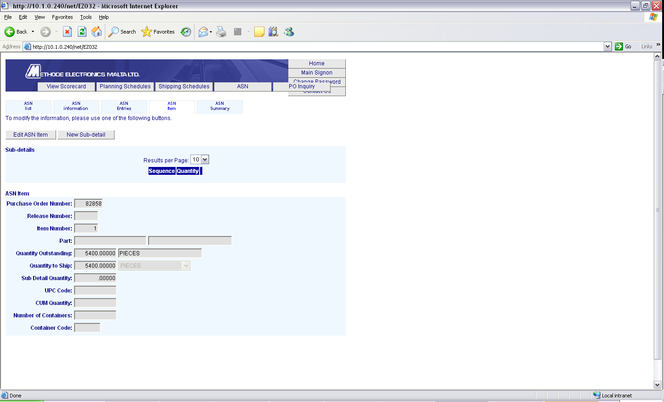
H. Press Tab
New Sub-Detail

- In the quantity field enter the quantity to be shipped. Optionally you can also enter a lot number for traceability. Should you have quantities from different lot numbers you can create different sub-details for this part. The quantities in the sub-detail screens must total up to the quantity entered in Part (F) above. Click the
Tab(K) to save your input data.
Save

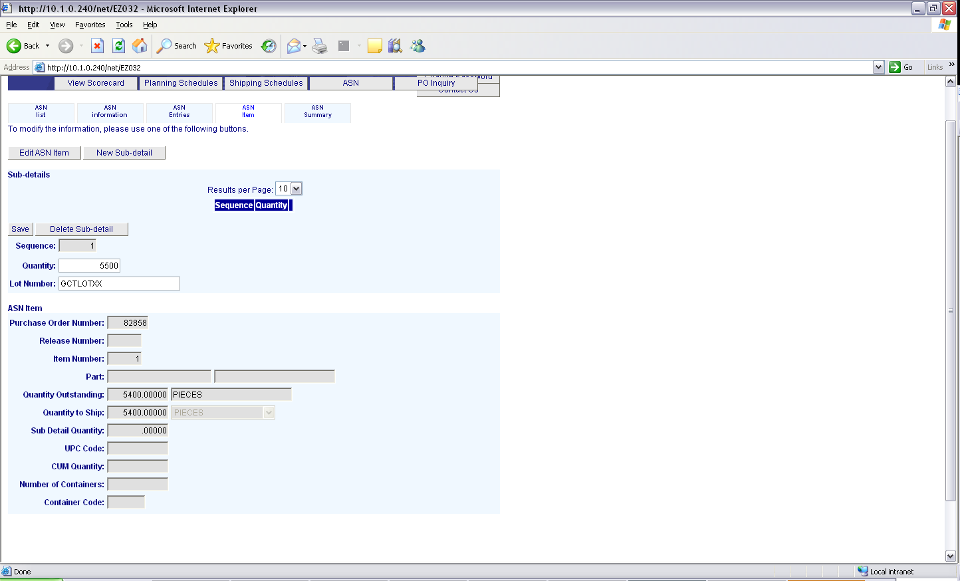
I. Enter Quantity
J. Enter Lot Number (Optional but recommended)
K. Click
Tab
L. Click
Tab Tab

- When ready with your data input click on Button as in (L) above. Check your data and should this be in order you can confirm your ASN by clicking on the Tab. At this point your data is submitted to Methode’s ERP system and no changes are allowed.
ASN Summary

Confirm ASN

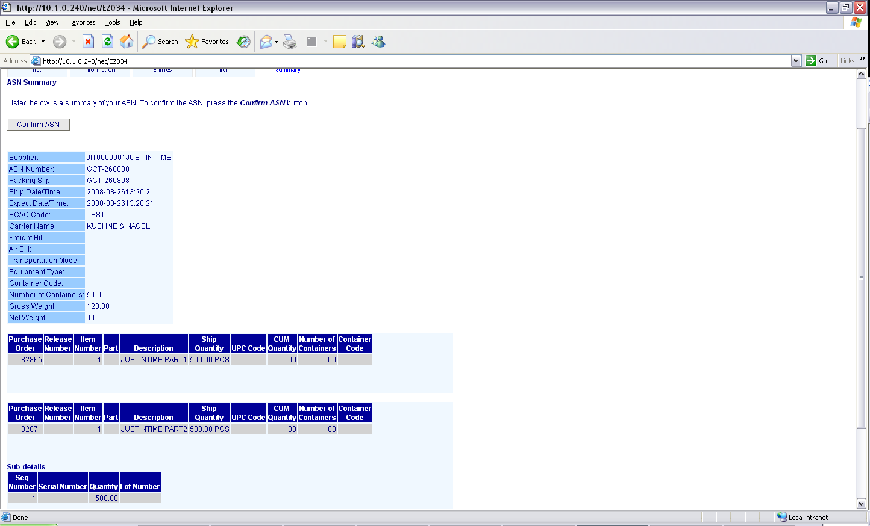
M. Click
Tab

- The Software will then take you to the original ASN Screen where you can print the labels. Click on Tab for the ASN you would like to print. It is important to know that the labels are specifically associated with the ASN created. Also, the labels represent data in Methode’s ERP system and this should not be tampered in any way.
Print Labels

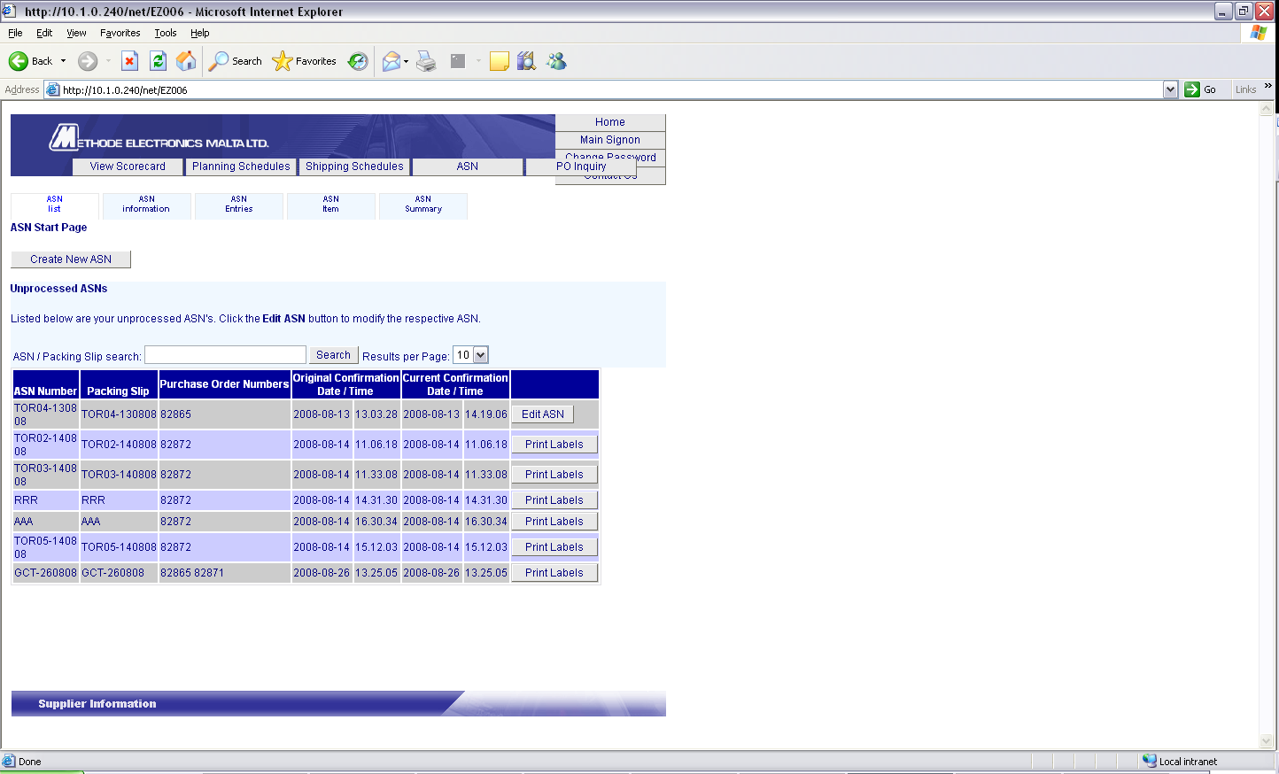
N. Click on

- In this screen you can print all the required serial labels with the following choices:
Print All Labels

Will print labels for all the ASN
Print Labels For Part

Will print labels for particular part
Print Label

Will print an individual serial label

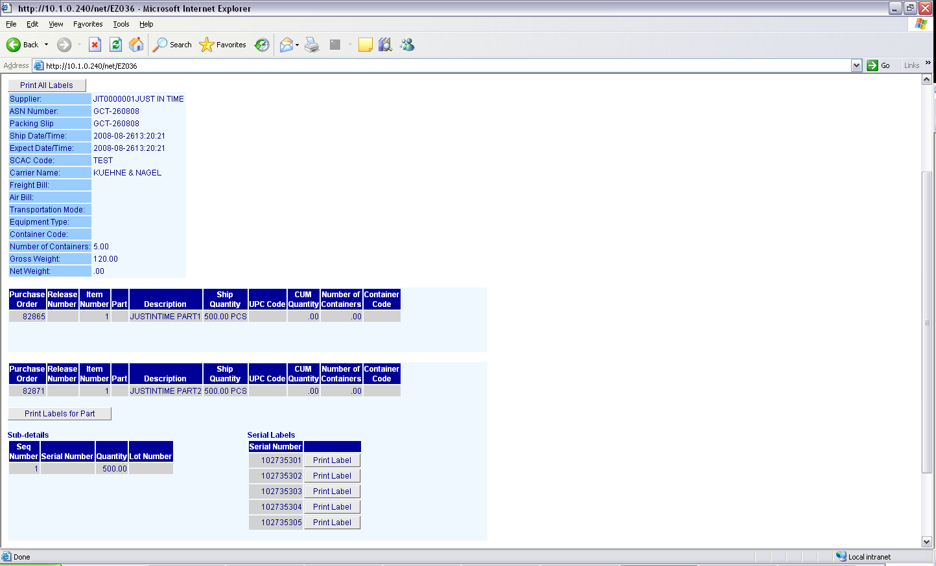
To Print Labels for a specific serial number click on corresponding ‘ Print Labels’ Tab
O. To Print All Labels for a specific part serial click on ‘ Print Labels for Part’ Tab
To Print All Labels click on ‘ Print All Labels’ Tab

- Once you click on a Label Tab a Printer dialogue screen will come up. Select the correct printer driver and select OK. It is essential that you have purchased the recommended printer as labels are specifically formatted for a particular printer. You would also need to install java which is freely available to download from the web.

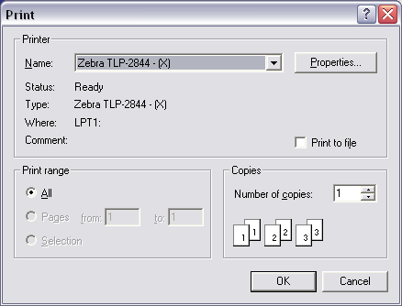

12. Output of label will be as below (please note that output below is for demonstration purposes only and actual output may be different from the example)

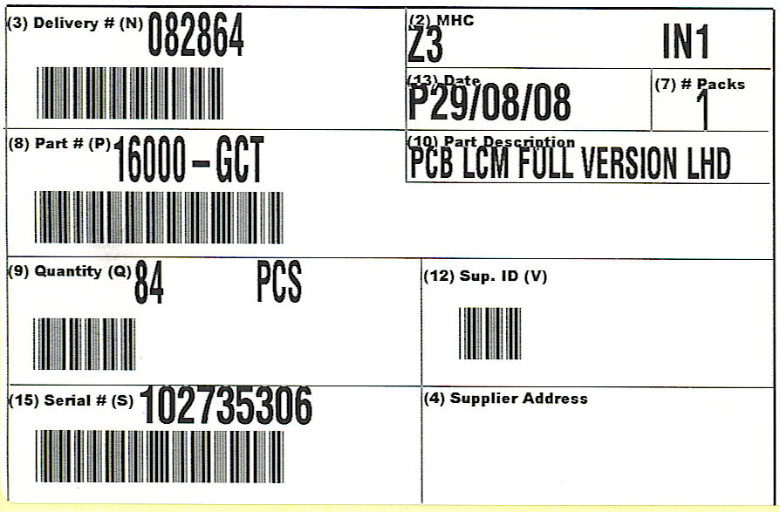
Frequently asked Questions

Q1) How does the system create the Shipping Labels?

A)The system takes the quantity being shipped for that item and divides this by the agreed standard pack. If the numbers are not exactly divisible the last label will have the remainder quantity.

Q21) We sometimes have a box on a shipment that falls below the standard pack; is it allowed?

- Whilst we not recommend shipping any boxes not in accordance to standard pack, the system can automatically cater for 1 non-standard pack per sub-detail item on the shipment as explained above.

Q3) Can we exceed the standard pack quantity?

- No you should never exceed the standard pack quantity.

Q4) We have changed the standard pack quantity what shall we do?

- You need to contact your material scheduler before you create an ASN so that this could be updated in our system. Any changes in standard pack can only take place by mutual agreement.

Q5) I have the recommended printer and software installed but the label does not want to print. What could the problem be?

- The system is missing or has some incorrect information eg the part is not set up correctly or there is no standard pack in the system. You should phone for support.

Q6) I tried printing on my laser printer but no label was printed

- The labels need to be printed on a specific label printer and cannot be printed on a normal laser printer.

Q7) I noticed that the information on the label does not tally with what there is in the box. Can I use a marker to correct your label.

A)No you must not touch the information on the label before contacting support. The information on the label is what we have directly received into our system and should not be modified without our knowledge.

Q8) We have been asked to ship some samples. How shall we handle this?

A) Samples should not be created on the same ASN as production parts. A separate ASN should be issued.

